Using the Quadratic Formula

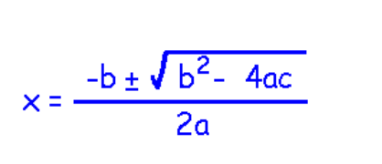
The roots of a quadratic equation in the form of ax² + bx + c = 0 can be found using the quadratic formula.

This formula produces 2 answers, which represent the 2 roots or zeros that a parabola would have. This formula will work on any quadratic expression, as long as it is in the expanded or standard form.

Sometimes, this formula will result in a negative number under the √ sign. When this happens, the calculation cannot be completed using ordinary numbers (called real numbers) but instead uses imaginary numbers. Imaginary numbers are a part of a larger set of numbers known as complex numbers, which are used in advanced mathematics.

In the quadratic formula, the value of b² - 4ac determines the number and type of roots a quadratic equation has. This expression is called the discriminant.
⇒If b² -4ac > 0, then it has 2 real roots

⇒If b² -4ac = 0, then it has 1 real root

⇒If b² -4ac < 0, then it has no real roots

You can also solve equations that have an x² if it is the only instance of a variable in the expression by isolating it and taking the square root.

Example - Solve 2x² + 5 = 167

Isolate the x² then take the square root. Remember that there are always two answers to the square root, the + and -.

Example - Solve x² = 16

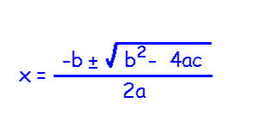
Solve the equation using the quadratic formula.

6x² - x - 15 = 0

a =

b =

c =

A digital sensor records the height of a baseball after it is hit into the air. Quadratic regression in the data gives the quadratic relation

y = -4.9x² + 20.58x + 0.491

How long is the ball in the air?

The ball hits the ground when its height is zero. Let y = 0
a =

b =

c =

The roots are:

Notice that one of the zeros is a negative, as it is an extrapolated value. The ball is actually in the air when it is hit, as is shown when x = 0.

Determine how many roots each equation has.

-5x² + 8x - 10 = 0 [Evaluate b² - 4ac (the discriminant)]

y = 2(x - 7)² - 12

Think of it logically, then prove using the discriminant.

Homework - Page 403 # 2odd, 4odd, 5, 6odd, 11, 12, 14

