Transformations of Quadratics

The relation of y = x² is the simplest quadratic relation. It is the base curve for all quadratic relations.
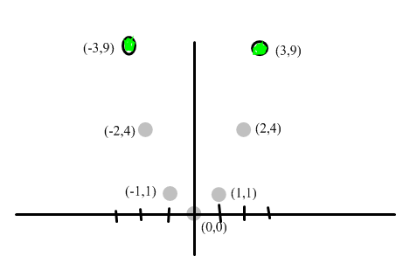
The graph of any quadratic relation can be created by altering and repositioning the above graph (y = x²).

Possible changes could be:
- shifting the graph up or down
- shifting the graph right or left
- vertically stretching or compressing the graph
- reflecting it about the x-axis (opening down instead of up)

These types of changes are called transformations.

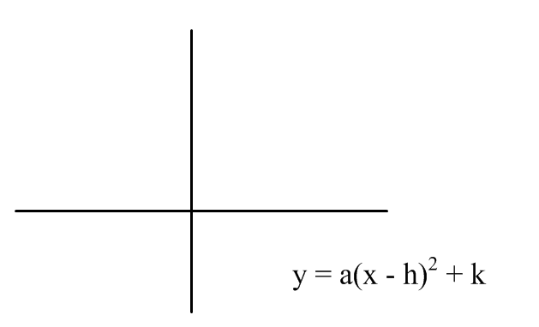
When a quadratic relation is in vertex form y = a(x - h)² + k, several properties of the graph of the relation are obvious.

k If k > 0, then the graph of y = x² is translated
up by k units. Similarly, if k < 0, then the graph
is translated down by k units

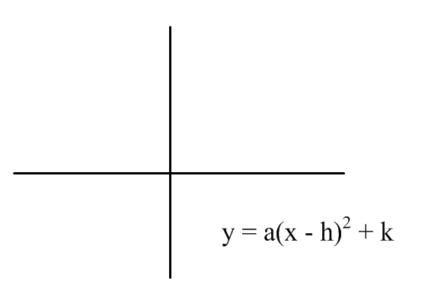
h If h > 0, then the graph of y = x² is translated
horizontally to the right by h units. Similarly,
if h < 0, then the graph moves horizontally to
the left by h units.

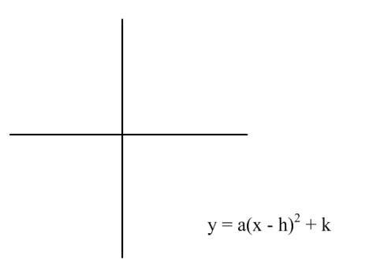
a If a > 0, then the curve opens up
If a < 0, then the curve opens down (reflected about the x-axis)
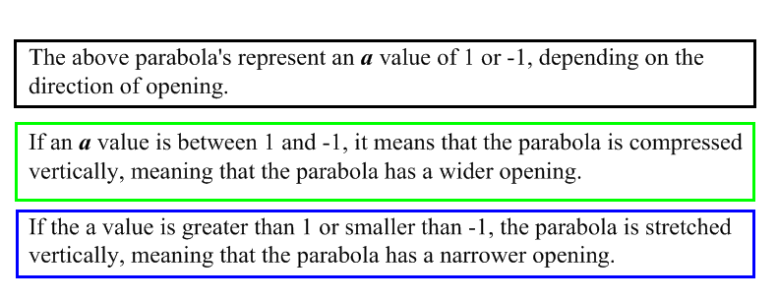

When you use transformations to graph y = a(x - h)² + k from y = x², apply the transformations in this order:

1) Translation left or right (h)
2) Vertical stretch or compression (a)
3) Reflection about the x-axis (+ or - a)
4) Translation up or down (k)

If a and k have opposite signs, then the graph has two x-intercepts (zeros), whereas if a and k have the same signs, then the graph has no x-intercepts (zeros).

Example:
For the relations below
i) state the vertex
ii) state the axis of symmetry
iii) state the direction of opening
iv) use the information from i-iii to graph the relation on graph
paper

- y = (x + 2)² – 4
- y = -2x² + 6
- ½ (x – 3)² – 1

Sketch the new graph that results from applying these transformations to y = x²

1) Translate 3 units to the left
2) Stretch vertically by a factor of 2
3) Translate up 1 unit

Then find the equation of the new graph.

Homework: Pg 363 # 1, 2, 3, 4, 5, 7

