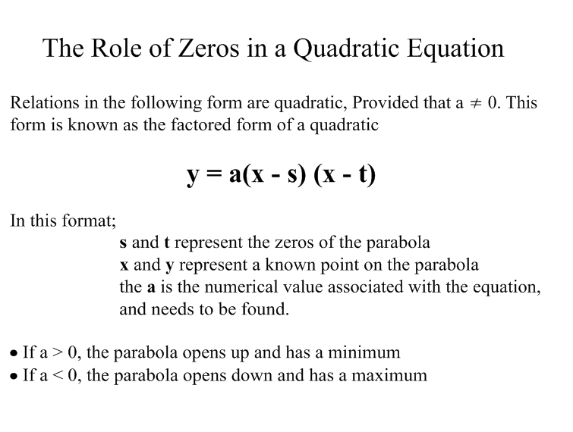

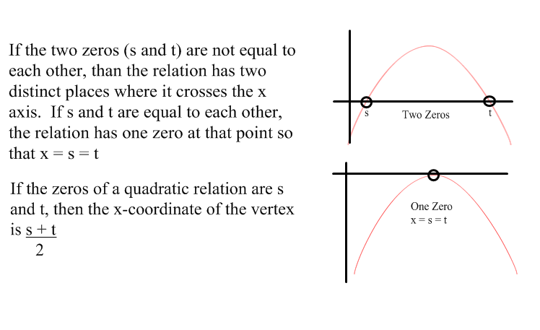

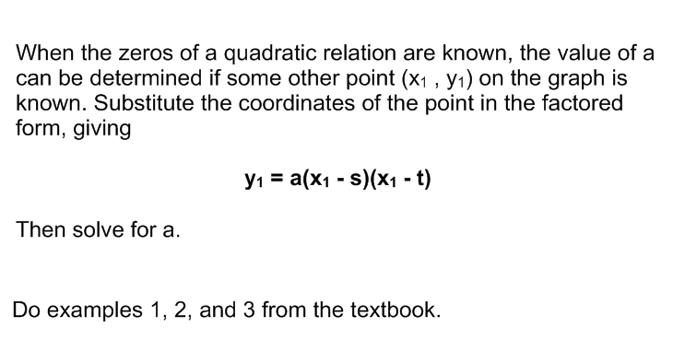

Homework

Day 1 - Pg 280 # 1 - 5

Day 2 - Pg 282 # 6, 7acegi,

8, 9acf, 12