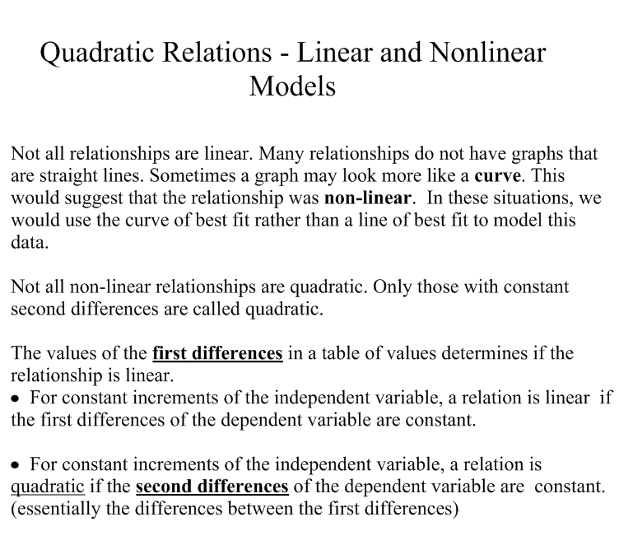

A linear relation models a phenomenon where the rate of change is constant. A nonlinear relation models a phenomenon with a variable rate of change.

The degree of a one-variable polynomial is the highest exponent that appears in any term of the expanded form of the polynomial.

For Example: 16w - 2w² ⇒ Degree of 2
2x⁴ + 4x³ + 8x² ⇒ Degree of 4
5x² (2x⁴ - 3x³ ) ⇒ Degree of 8

A polynomial of degree 2 models a quadratic relation.

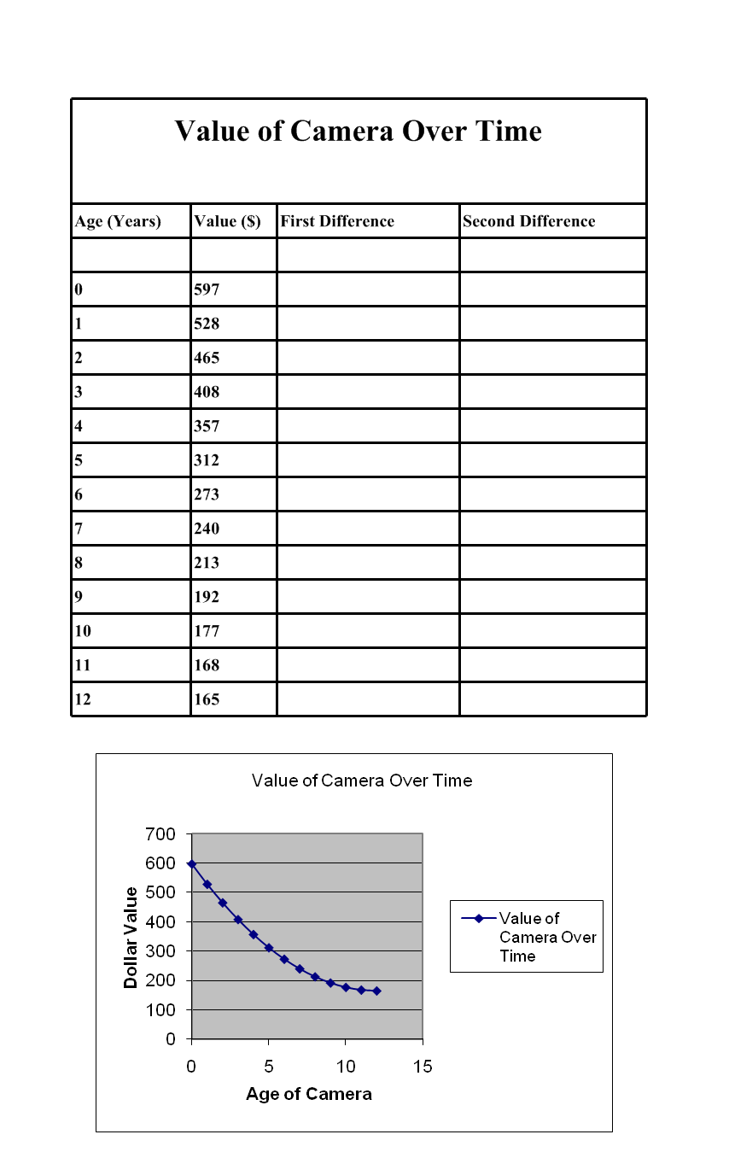

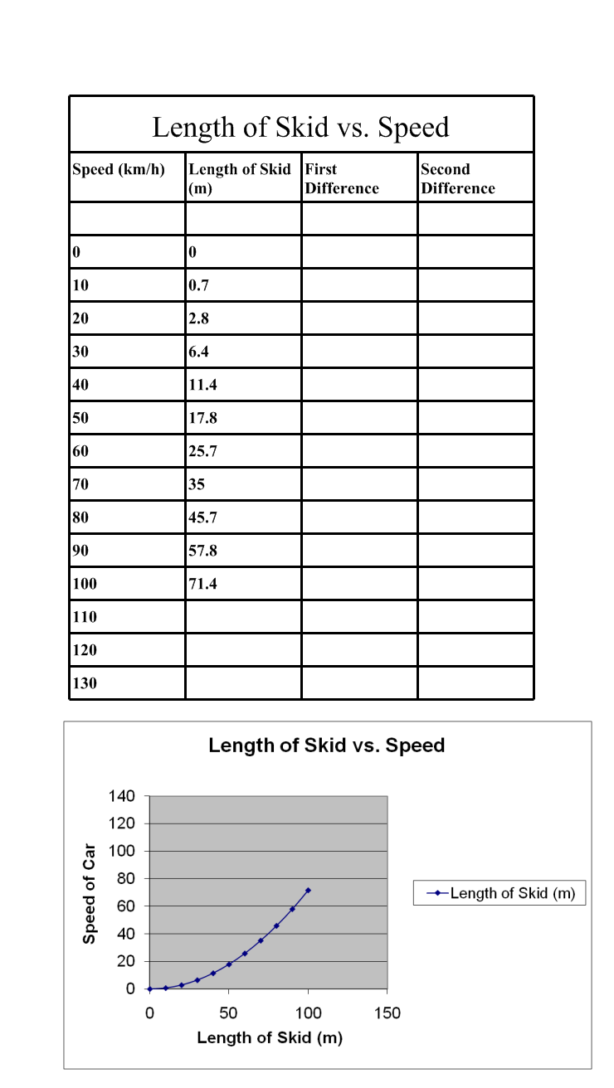

Homework

Page 254 # 1, 2, 5, 6, 8, 9, 12, 16

