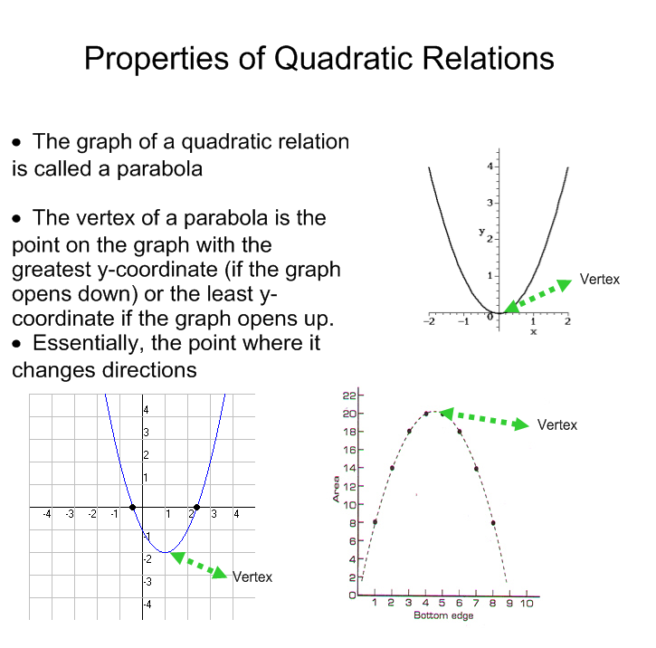

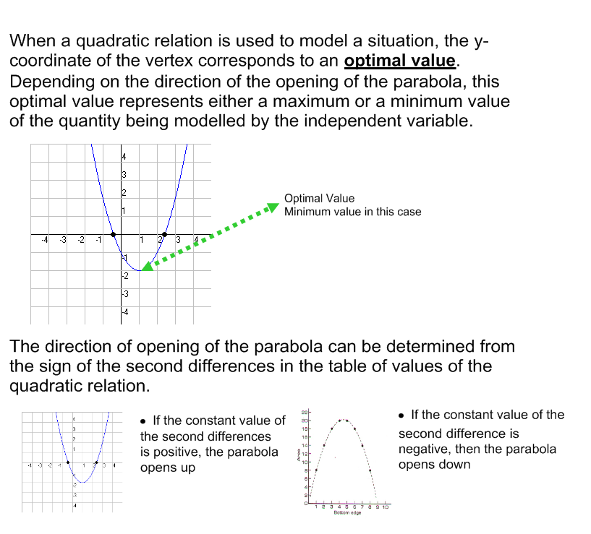

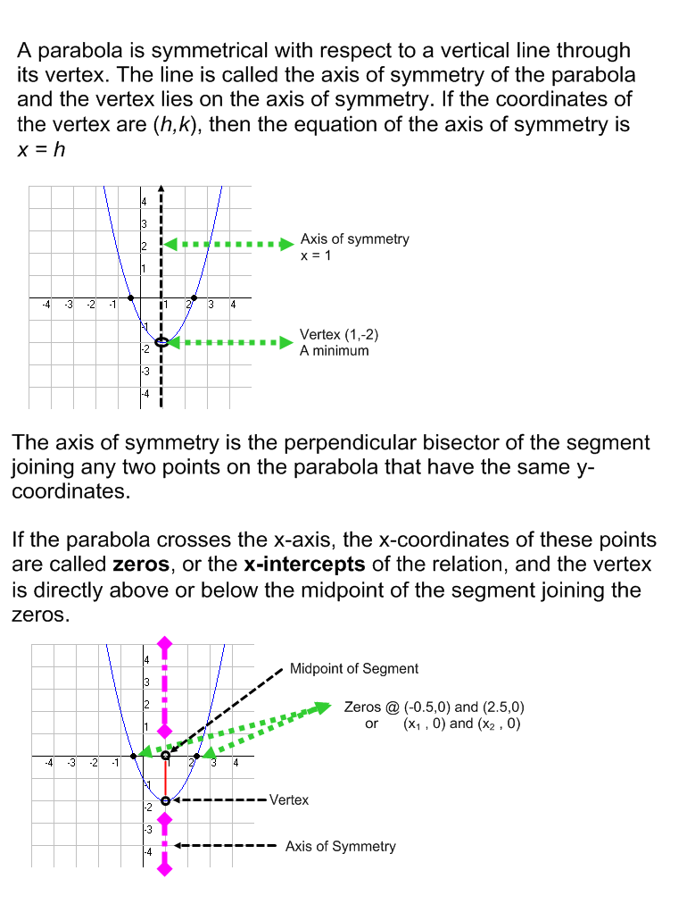
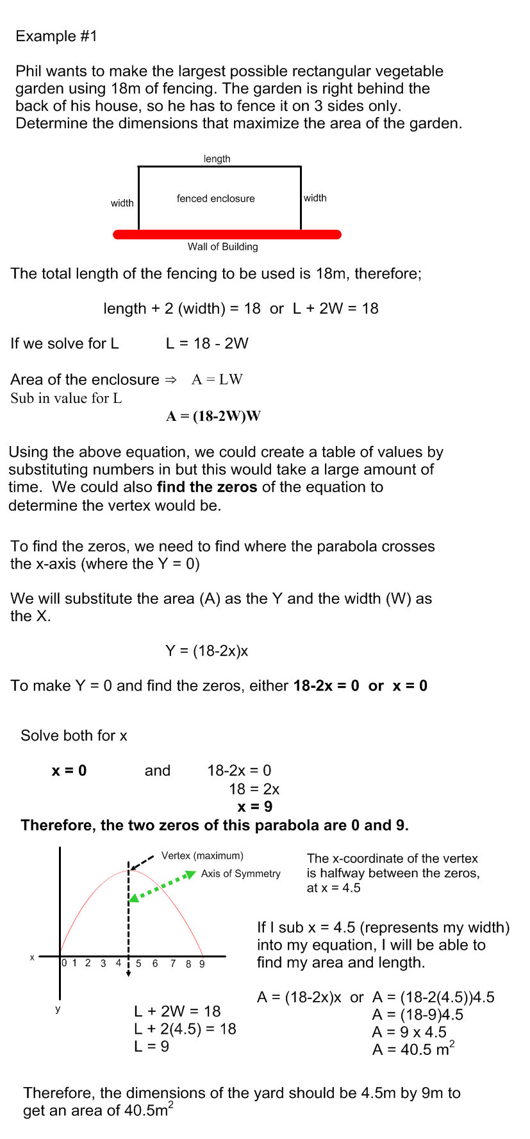
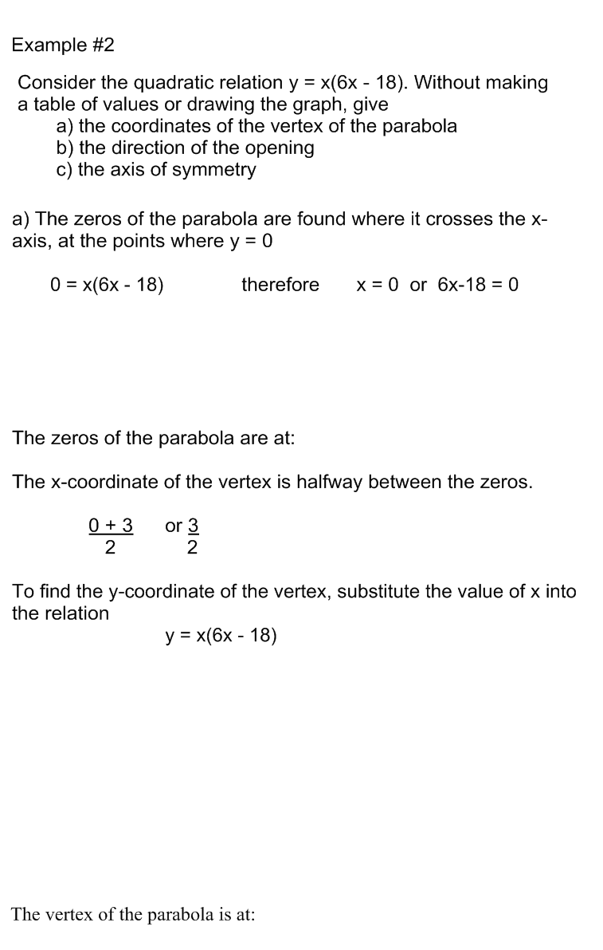

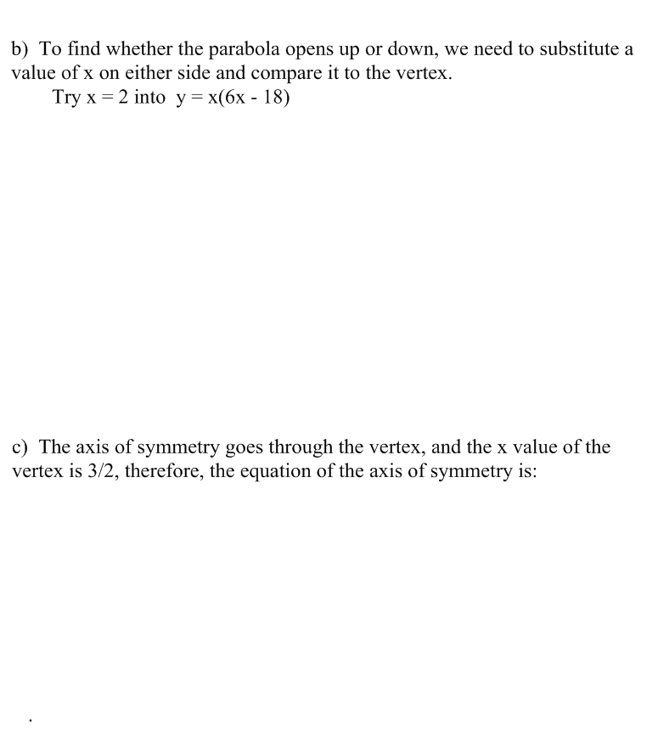

Homework:

Day 1 (Monday, May 7)
Page 266 # 1(state why), 2, 3, 4, 5

Day 2 (Tuesday, May 8)
Page 267 # 6, 7, 8, 9, 10acg, 15 (remember to factor first)

