Notebook Questions – Demographics

- If the target market for hiking boots were the extreme hiker, name one medium and one promotion that would allow you to target that group specifically.
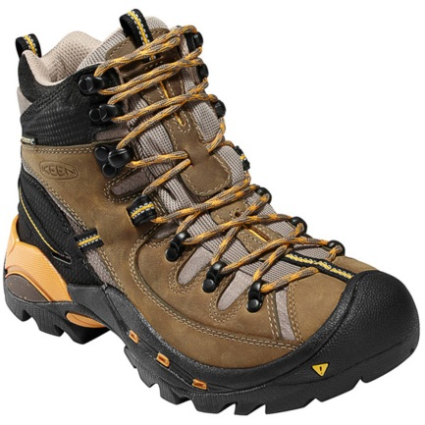
Medium:

Promotion:

- Describe your personal demographic as much as you can.

Age:

Gender:

Family Life Cycle:

Income Level:

Ethnicity and Culture:

- Name 3 products that you buy that you think reflect your demographic group. Explain your choices briefly in one or two sentences.

Product 1:

Product 2:

Product 3:

- Given the following products, try to specify the appropriate consumer segment

Can-Am ATV -
Covergirl Mascara –
Depends –
Red Bull Energy Drink –
Mercedes Benz –
Kellogg’s Vector Cereal –
Life Insurance Agent –
Organic Apples –
Disney Pixar Movie –

