MPM2D1 – Grade 10 Math
____ ____
18 9
K/U C
Solving Linear Systems Assessment

- Solve the following System using the graphing method. Show your work!
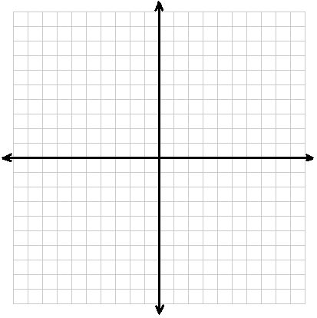
3x = 12 – 9y
3y = 4x + 6

- Solve the following system using the substitution method. Show your work!
2x + 3y – 9 = 0
x – y – 2 = 0

- Solve the following system using the elimination method. Show your work!
4x + 3y = 13
5x – 4y = -7

