Factoring Quadratic Expressions of the Form x² + bx + c

To factor a quadratic expression of the form x² + bx + c, first find two integers whose product is c and whose sum is b.

Think of the expression x² + bx + c = (x+r)(x+s), where r+s = b and r * s = c

Example 1 - Factor Quadratic Expressions
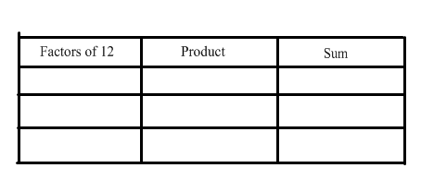
Factor if possible:

a) x² + 7x + 12

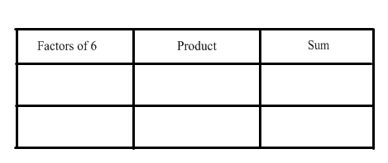

b) x² + 4x + 6

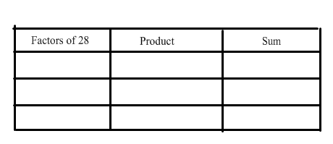

c) x² - 29x + 28
Since the sum is neg and the product
Is positive, the factors must be
negative

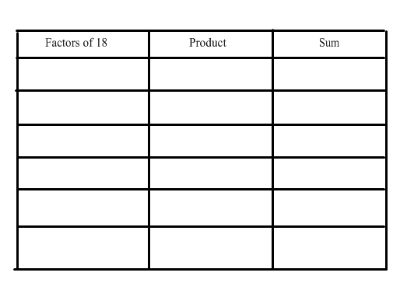
d) x² + 3x - 18

Example #2 - Word Problem

Determine the binomials that represent the dimensions of the rectangular water garden whose area is expressed as x² + 5x + 6.

Determine the dimensions if x represents 1m.
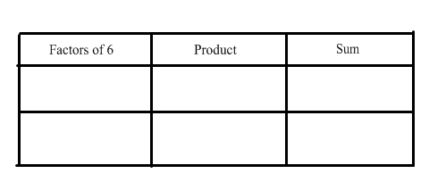

Homework

Attached Handout # 1,2,3,4,5,6,7,8ac,9ac

