Factoring Quadratic Equations of the Form
ax² + bx + c
The theory behind the operation:

When you expand 2 binomials, you add the 2 middle terms.

(2x + 3)(3x + 4) = 6x² + 8x + 9x + 12
= 6x² + 17x + 12

Notice the following pattern:
8 + 9 = 17 and 8 x 9 = 6 x 12 = 72

We can use this pattern to help us factor trinomials that have a≠1.

Example 1 - Break up the middle term

Factor 3x² + 8x + 4 remember the general form ax² + bx + c

a = 3, b = 8, and c = 4

First we need to multiply a x c to get the number we are finding the factors for.
3 x 4 = 12

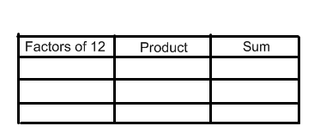
Now we need to find the two factors that produce a product of 12 and a sum of b which is 8.

Since the integers 2 and 6 satisfy this product and sum, we can break up 8 x from the equation into 2x and 6x. Then we factor by grouping.

3x² + 8x + 4
= 3x² + 2x + 6x + 4
= (3x² + 2x) + (6x + 4)
= x(3x + 2) +2(3x + 2)
= (3x + 2)(x + 2)
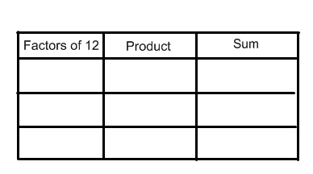
Factor 3x² + 2x + 4

a = 3, b = 2, c = 4

3 x 4 = 12, therefore looking
for factors of 12 that add to
2

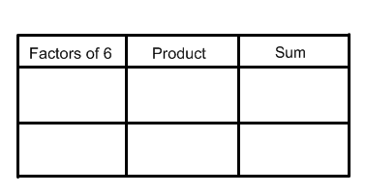
Factor 6x² - 5x + 1

a = 6, b = -5, c = 1

6 x 1 = 6, therefore looking
for factors of 6 that add to
-5

Once we have found the two integers, sub them in for the value of b.

6x² -5x + 1

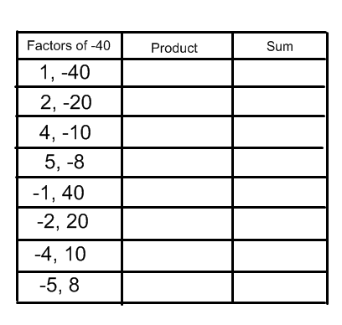
=

Example #2 - Trinomials with Two
Variables

Factor 10x² - 3xy - 4y²

a = 10, b = -3, c = -4

10 x -4 = -40, therefore looking
for factors of -40 that add to -3

Once I have the integers, I can substitute them in for the value of b. Then I will factor by grouping.

10x² - 3xy - 4y² =

Example 3 - Remove a Common Factor

Factor 16x² + 26x - 12

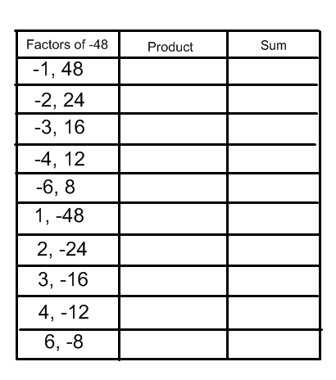
First remove the greatest common factor, then proceed as we have been doing.

16x² + 26x - 12

= 2(8x² + 13x - 6)

8 x -6 = -48 therefore looking for
factors of -48 that add to 13.

Once we have the 2 integers, we substitute them in for the value of b. Then we factor by grouping.

16x² + 26x - 12 = 2(8x² + 13x - 6)

=

Key Concepts

- Always look for a common factor first when factoring a trinomial
- to factor ax² + bx + c, find 2 integers whose product is a x c, and whose sum is b. Then, break up the middle term and factor by grouping.
- Not all quadratic expressions of the form ax² + bx + c can be factored over the integers

Questions

Day 1 - Handout # 1-4

Day 2 – Handout # 5,6,7,10,12,13,16

