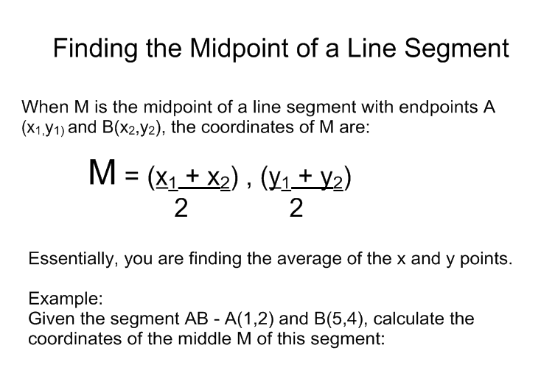

Determine the coordinates of the midpoint M between the following points:
A) A(5,5) and B(7,3)

B) C(6,-5) and D(-2,9)

C) E(8,-1) and F(9,4.5)

D) G(-6,-6) and H(-2,-7)

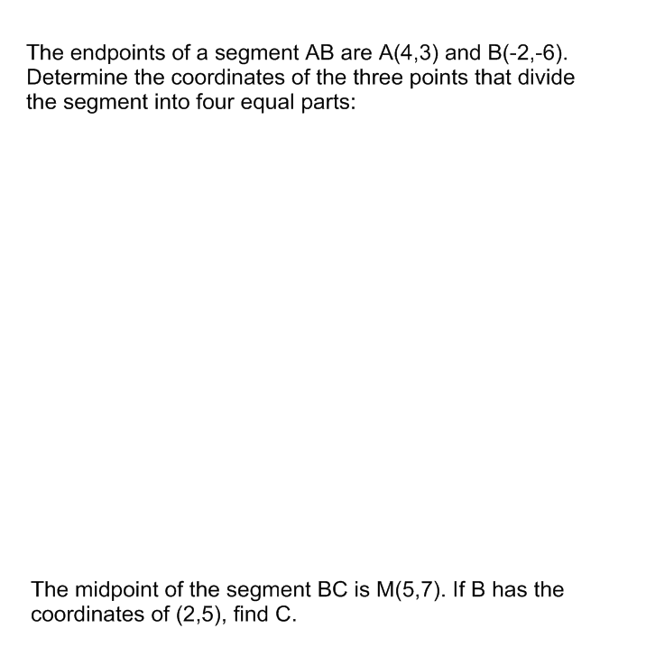

Homework
Pg 173 # 2aceh, 3, 5, 6, 9, 11

