Experiment with Headers and footers (see above). You can have the same header/footer for every page, a different first page, or different ones for different sections (see below). Headers are great places to put images like company logos!

Sections are a way to organize a document. The second page of this document is a “new section” with a different header/footer and page style. To insert a new section use the Page Layout Breaks Next Page option and choose the break you want (in this case a new section). Sections can be used for chapters or to prevent chunks of the document from being shifted out of format when you modify an earlier section.

Bookmarks are a good way to remember a specific location in a large document, such as the beginning of a chapter. To use a bookmark you need to insert a bookmark and then link to it (see hyperlinks below). To insert place the curser where you want the bookmark to be and use the Insert/Bookmark option:
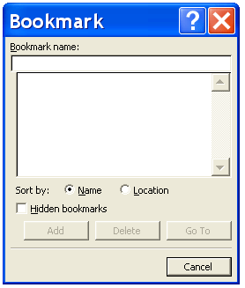
Your other bookmarks will show up here
Give it a name (one that you’ll remember or recognize)

Hyperlinks are useful for groups of documents or for large documents you can insert a hyperlink to point to a new document, webpage or to a point within a document to a bookmark:
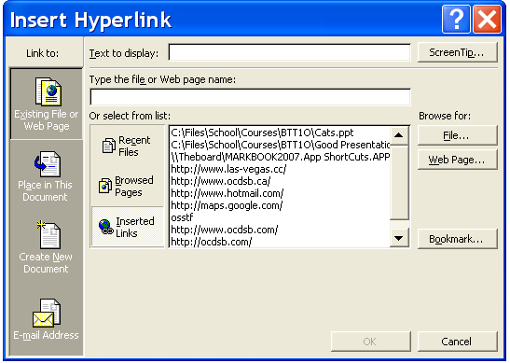
To move to a new document or bookmark, highlight a word and Insert/Hyperlink the following window appears:
Highlighted Text in your document
Browse for either a file on your PC or the Internet for a web page
Use this to find a spot in the document. The bookmark must already exist!
Link to a document
Link within a document
Type the name or use the browse feature

In your document the link will now appear blue and underlined like this link to page 2

Create a document on your own with:
- Your name in the header
- Automatic page numbers in the footer
- A section break to a new page
- A bookmark and link to the new page
- Just cut and paste some text from the web for your document
Page 2
This page is landscape oriented rather than the normal portrait orientation.

Equations, as we write in math class, can be easily done with the word equation editor (may need to install as an add on) and lets you create great looking equations like this:
To insert an equation go to Insert Equation

Try adding the quadratic formula equation in your document, then add a custom equation that matches the format of the quadratic equation but uses different letters. (Insert Equation Insert new equation then put the script in that matches – this will take some time to figure out)

References (bibliography) can be a huge pain to add to a paper you have written, but Word has a neat tool that helps you enter them in the correct format. Go to the References tab and choose Insert Citation Add new source.

Results Now by Mike Schmoker
Published by Association for Supervision and Curriculum Development in Alexandria, Virginia © 2006

Insert the citation for the above book in APA 5th ed. and Chicago 15th ed.

You can indent an individual paragraph by using the Page Layout Indent.
You can indent the entire page by using the Page Layout Margins

Increase the size of your left / right margins on the page to 7 cm
Increase the left / right indent of one paragraph to 10 cm

