Culminating Activity

This unit is the culminating challenge for applying knowledge and skills in ways that display your creativity and reflection on the course material. You will create a brief survey on an ethical issue related to information and communication technology. The following four activities will allow you to tabulate the results, process the data, and then present the information in a meaningful way through web design and presentation software. This unit will give you a chance to express your creativity while demonstrating the mastery of course expectations.

Part 1 – Word-Processed Survey

Create a ten question survey on a social or ethical issue related to information and communication technology. The survey must be a word processed document. Some suggested topics are listed below. Please ensure your teacher approves your topic before you start working on the survey.

Your survey should include the following:
- At least three demographic questions (eg. age, sex, education levels of your respondents).
- At least five opinion questions (eg. ask respondents their opinions on a number of questions associated with the social or ethical issue).
- At least two product usage questions (eg. If you are conducting a survey on file sharing, you may ask respondents what types of file sharing programs they have used in the past, or the frequency of using these programs).

Some suggested survey topics:

Recycling of electronic devices
File sharing (i.e. mp3 downloads from non-pay sites)
E-business security
Personal privacy
Cyber bullying
Online safety and security
Identity theft
Cyber stalking
Spy ware
Any other topic your teacher approves

- When you have completed your survey, send it to your instructor. Your instructor will review the survey and offer suggestions for improvement.
- Send your revised survey to all students in your class and to your instructor electronically.
You are responsible for completing the survey of every student in the class.
- Please return completed surveys to the student who created it via email in a timely manner. The survey results are required for the second activity of this culminating task.

Part 2 – Data Analysis Using a Spreadsheet

Now that you have created your survey and have the results back from other students in this class, you can tabulate and make sense of the results.
- In a new spreadsheet file, tabulate the results of all your survey questions. Remember that your survey has ten questions, so you must tabulate the results for all ten of those questions.

Here is how the results might look as they are tabulated in your spreadsheet (this is just an example to give you an idea of how it might look):
Question 1: Have you ever downloaded mp3 files using a file sharing program such as Lime Wire?
 | Males | Females
Yes | 12 | 7
No | 3 | 8
 | 15 | 15
In the above question, twelve male respondents and seven female respondents said they had downloaded mp3 files using a file sharing program in the past. Three male respondents and eight female respondents stated that they had not downloaded mp3 files using a file sharing program in the past. The total of all male and female respondents adds to thirty so you know that thirty people answered this particular survey.

Please note that you are not required to comment on the data or discuss any correlations or trends; at this point, you are only required to organize the data into tables so that it can be used later.

- Make use of at least two formulas or functions you have learned in this course within your tabulated results. For instance, you may want to use the SUM function of a formula to add the data in columns or rows.
- Create a graph for each question in your survey. A graph for the above question might look like this:
The graphs for each question could look like any of the following:
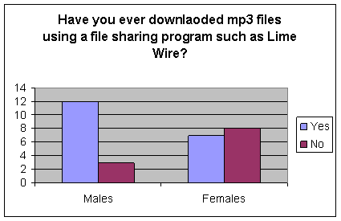
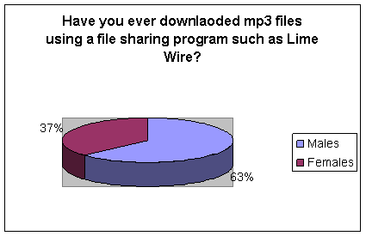
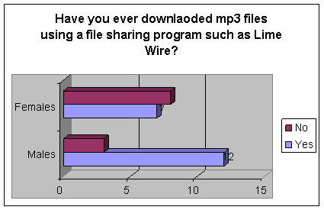

The graph type and style is up to you to decide. Please ensure that the graph includes a title (the actual survey question) and data values (percentages or numbers, etc.).
The graphs should be placed in the spreadsheet below the tabulation results for each question.

Part 3 – Presentation and Report

For this assignment, you will use presentation software (PowerPoint or Prezi) to create a report based on your survey data. You will need to refer to the spreadsheet created in Part 2.

- Create a title slide
  - Create a large 3D title with the Font tool. Put this in the centre of the slide.
  - Towards the bottom of this slide, print your name and class information in a smaller font.
- Create an introduction slide
  - Using a bulleted list, briefly summarize your topic.
- Create two more new slides
  - On the first new slide, paste the most interesting graph from your spreadsheet in Part 2. Explain what is interesting about this graph (use at least two to three bullet points on your slide).
  - On the second new slide, paste the actual data for the chart that you have just inserted.
- Create a summary slide
  - Using a numbered list, summarize at least three interesting trends or correlations found in your survey results. Only list the trends; do not explain them yet.(For example: a survey on poverty might discover that more males live below the poverty line than females, or that poor female students are more likely to take part in athletic activities than those who are better off financially.)
- Create a conclusion slide
  - Based on the trends listed on your previous slide, list several conclusions and/or recommendations related to your topic (between two and four bullet points). Your recommendations should answer questions such as:
- What do these trends mean for society?
- How can we deal with any negative trends or how can we make the positive trends work most effectively for the common good?
- Whose responsibility is it to make any necessary changes regarding this issue? In your opinion, what should be done?
  - If necessary, you may use two slides for the conclusion (if you run out of room).
- Record an audio narration for your presentation. Most of your slides use bullets or numbered lists, so your dictation should be more detailed than the information on the slide. Do NOT just read the text on the slides:
  - Use language and etiquette appropriate to a general audience.
  - Speak clearly and be honest about your findings.
  - Engage your audience by verbally emphasizing your most important points.
  - If you do not have a microphone available, please create a written script in place of the audio narration. Place the written script in the notes pages of the presentation.

- Complete your presentation
  - Apply an effective colour scheme (ensure that there is a good contrast between the background and the text).
  - Apply some simple animations and transitions. Do not use animations or transitions that are flashy or take a long time to occur.
  - Insert at least two images taken from the internet into slides where they are applicable. Be sure to use images that are not copyright and are legally free to copy.

Part 4 – Publishing / Cover Page

“The first impression will either open the door or close it. It's that important, so don't mess it up!” -Nicholas Sparks

A cover page is the first thing readers will see when they look at a report. Whether the pages that follow are a formal essay or an informal assignment, the cover page is often a good indicator of the quality of the rest of the project. Making a good first impression is crucial!

In this part, you will use Photoshop or Publisher to create an eye-catching, professional cover page for your survey report.

In the previous activity, you created a report which could be presented to a live audience. Reports like this are often produced in a hard copy format (on paper) so that the audience can take notes or have a physical version of the presentation to refer to at a later time. Assuming that this is the case, you will use desktop publishing software (Photoshop or Microsoft Publisher) to create an eye-catching, professional cover page for your survey report. (You will not actually need to print the report from the previous activity).

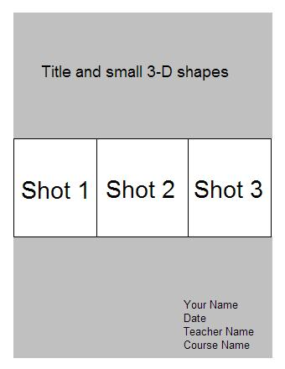
- Create a new, blank desktop publishing document. The size of the page should be 8.5” X 11”, or “standard letter.”
- Insert a rectangle shape that covers the whole page except for a 1cm border around the edges. Shade this shape with a 2-colour gradient fill. Use light colours or set transparency on the whole shape so that the shading is faded out.
- Create a centred title with 3-D text roughly 1/3 of the page down from the top.
- Place a small 3-D shape on either side of this title.
- Open your excel file from activity 2 and copy one of the most interesting slides, and then paste it into the desktop publishing document. If copy and paste does not work well on your computer, you may also transfer the slides by taking screenshots. (Remember; the PrintScreen button copies a screen which may then be “Pasted” into a new document.) The other 2 pictures are to be related to your topic and at least one must have you “photoshoped” into it. Put the three copied slides side by side across the centre of the desktop publishing document. You will need to resize them so that they fit evenly (see illustration)
- Finally, at the bottom right hand side of the document, insert text for your name, the current date, your teacher’s name, and the course code, BTT1O. Make sure that your colour scheme has good contrast and that all of your text is legible (easy to read).

Part 5 – Web Page Creation

For this final part of the culminating activity, you will create a webpage that summarizes your topic and work in this assignment.

- Create a new webpage using Weebly (may need to go to www.weebly.com and sign up for account
- Give your page an appropriate title (the words that show up in the blue bar at the top of the window), as well as a heading that displays at the top of the body of the page. The heading should be in an appropriately sized, sans-serif font style.
- Below your heading, write a one paragraph overview of your survey topic. (Briefly explain the background or nature of the issue and why it is an important topic). This must be in your own words – it is not acceptable to copy directly from another source.
- Insert an image which represents your topic. This image must be public domain (free for you to copy). Save the image on your M-drive and link this image locally; do not link directly to an external website. (that way it is available even if the picture you copied is moved or deleted)
- Insert your Photoshop cover page image onto this page
- Below the image, create a two-columned numbered list with two links to external webpages where viewers can learn more about this topic. These lists should each have a sentence (above the list) that explains what the links are for.
- At the bottom of the page, write the date and insert an email address link for anyone who needs to contact you for more details. (For this assignment, use a fake email address such as contactme@ficticious.com
- Create a new page that is linked to the home page and call it “Survey Results”
  - Include a copy of your survey as a PDF file
  - Include the screenshot pictures of each of the 5 most interesting graphs you created in part 2 (5 separate pictures) each with a caption that summarizes the findings
  - Include your excel chart and your PowerPoint presentation as a downloadable file on the page
  - Write a paragraph that summarizes the most interesting result(s) of your survey project. This section should be 3-5 sentences long. You may comment on the results of your survey or the actual process of completing activities 1 to 5 of this assignment
- Last step is to publish your website, that way Mr. Bourne can see it and mark it.

Part 1 – Word Processed Survey

Social / Ethical Issue Survey
Category / Criteria | Level 1  (50 - 59%) | Level 2  (60 - 69%) | Level 3  (70 - 79%) | Level 4  (80 - 100%)
Knowledge and Understanding: Knowledge of the three types of survey questions | Demonstrates limited knowledge of the three types of survey questions | Demonstrates some knowledge of the three types of survey questions | Demonstrates considerable knowledge of the three types of survey questions | Demonstrates thorough knowledge of the three types of survey questions
Thinking: Uses effective planning skills in gathering of information | Uses planning skills with limited effectiveness | Uses planning skills with some effectiveness | Uses planning skills with considerable effectiveness | Uses planning skills with a high degree of effectiveness
Communication: Organizes survey in a clear and logical manner | Organizes survey with limited effectiveness | Organizes survey with some effectiveness | Organizes survey with considerable effectiveness | Organizes survey with a high degree of effectiveness

Part 2 – Data Analysis Using a Spreadsheet

Data Analysis using a Spreadsheet
Category / Criteria | Level 1  (50 - 59%) | Level 2  (60 - 69%) | Level 3  (70 - 79%) | Level 4  (80 - 100%)
Communication: Organization of information | Organizes information with limited effectiveness | Organizes information with some effectiveness | Organizes information with considerable effectiveness | Organizes information with a high degree of effectiveness
Application: Application of spreadsheet knowledge and skills | Applies spreadsheet knowledge and skills with limited effectiveness | Applies spreadsheet knowledge and skills with some effectiveness | Applies spreadsheet knowledge and skills with considerable effectiveness | Applies spreadsheet knowledge and skills with a high degree of effectiveness

Part 3 – Presentation and Report

Presentation / Report
Category / Criteria | Level 1  (50 - 59%) | Level 2  (60 - 69%) | Level 3  (70 - 79%) | Level 4  (80 - 100%)
Knowledge and Understanding: Demonstrates understanding of a chosen topic by providing an accurate introduction slide | Demonstrates limited understanding of topic | Demonstrates some understanding of topic | Demonstrates considerable understanding of topic | Demonstrates thorough understanding of topic
Thinking: Critical Thinking is employed (synthesizing, forming conclusions) to summarize data trends and present meaningful conclusions or recommendations | Uses critical thinking skills with limited effectiveness | Uses critical thinking skills with some effectiveness | Uses critical thinking skills with considerable effectiveness | Uses critical thinking skills with a high degree of effectiveness
Communication: Written and verbal communication follows conventions of spelling and grammar correctly, using appropriate vocabulary where applicable.  Expression and organization of ideas:  - Dictation is clear and engaging.  - Language and vocabulary are appropriate to the topic and audience.  Dictation is accurate and more detailed than printed text. | Uses conventions of spelling, grammar and vocabulary with limited effectiveness  Expresses and organizes information with limited clarity and accuracy | Uses conventions of spelling, grammar and vocabulary with some effectiveness  Expresses and organizes information with some clarity and accuracy | Uses conventions of spelling, grammar and vocabulary with considerable effectiveness  Expresses and organizes information with considerable clarity and accuracy | Uses conventions of spelling, grammar and vocabulary with a high degree of effectiveness  Expresses and organizes information with a high degree of clarity and accuracy
Application: Applies presentation design skills to create an effective, appealing report. | Applies design skills to the presentation with limited effectiveness | Applies design skills to the presentation with some effectiveness | Applies design skills to the presentation with considerable effectiveness | Applies design skills to the presentation with a high degree of effectiveness

Part 4 – Publishing / Cover Page

Publishing / Cover Page
Categories | Level 1  (50 - 59%) | Level 2  (60 - 69%) | Level 3  (70 - 79%) | Level 4  (80 - 100%)
Communication: Organization of information:  - layout and design are effective  - colour scheme is attractive and does not obscure text | Organizes information with limited effectiveness | Organizes information with some effectiveness | Organizes information with considerable effectiveness | Organizes information with a high degree of effectiveness
Application: Application of desktop publishing knowledge and skills | Applies desktop publishing knowledge and skills with limited effectiveness | Applies desktop publishing knowledge and skills with some effectiveness | Applies desktop publishing knowledge and skills with considerable effectiveness | Applies desktop publishing knowledge and skills with a high degree of effectiveness

Part 5 – Web Page Creation

Web Page Creation
Categories | Level 1  (50 - 59%) | Level 2  (60 - 69%) | Level 3  (70 - 79%) | Level 4  (80 - 100%)
Knowledge and Understanding: Demonstrates understanding of a chosen topic from ethical or social issues | Demonstrates limited understanding of topic | Demonstrates some understanding of topic | Demonstrates considerable understanding of topic | Demonstrates thorough understanding of topic
Thinking: Critical Thinking is employed (synthesizing, forming conclusions) to summarize the main topic as well as each activity displayed in the table | Uses critical thinking skills with limited effectiveness | Uses critical thinking skills with some effectiveness | Uses critical thinking skills with considerable effectiveness | Uses critical thinking skills with a high degree of effectiveness
Communication: Utilizes language conventions of spelling and grammar correctly, using appropriate unit vocabulary and terminology where applicable Expression and organization of ideas:  - uses a title that communicates information and ideas with clarity and sense of audience and purpose;  - selects an image and internet links appropriate to the topic. | Uses conventions of spelling, grammar and vocabulary with limited effectiveness  Expresses and organizes information with limited clarity and effectiveness | Uses conventions of spelling, grammar and vocabulary with some effectiveness  Expresses and organizes information with some clarity and effectiveness | Uses conventions of spelling, grammar and vocabulary with considerable effectiveness  Expresses and organizes information with considerable clarity and effectiveness | Uses conventions of spelling, grammar and vocabulary with a high degree of effectiveness  Expresses and organizes information with a high degree of clarity and effectiveness
Application: Applies web design skills to create an effective, appealing website. | Applies web design skills to the website with limited effectiveness | Applies web design skills to the website with some effectiveness | Applies web design skills to the website with considerable effectiveness | Applies web design skills to the website with a high degree of effectiveness

